Section 4(ii) & (iii) | Team Structure, Experience and Qualification of the Team
6.0 | Property Management Services Provider
6.1 | Student Engagment and Communnity Services Provider

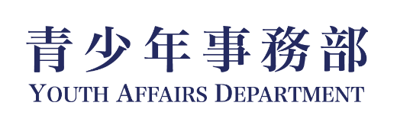
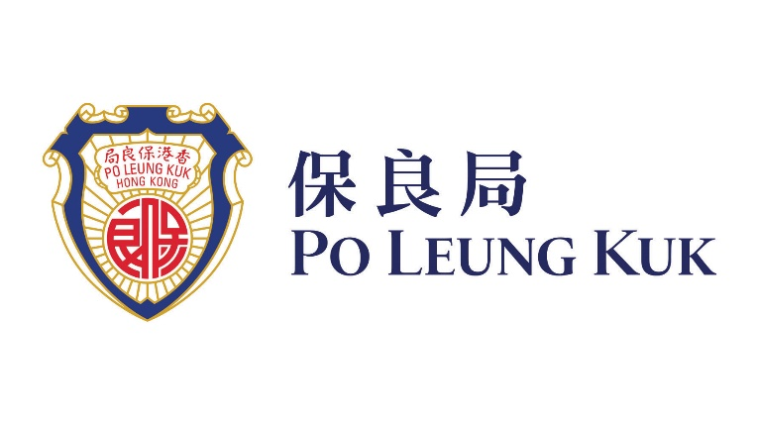

Company Profile

Po Leung Kuk (保良局) is one of Hong Kong’s largest and most reputable non-profit organisations, with a proud heritage spanning 148 years. Today, it operates 325 service units covering a wide spectrum of community needs, including education, social services, youth development, medical and integrated health services, as well as recreational and cultural services.

Over the past three years, Po Leung Kuk has served an average of more than 3 million service users annually, reflecting both the scale of its service network and the strength of its long-established service foundation. With deep roots in the community and a strong commitment to public service, Po Leung Kuk continues to deliver impactful, people-centred services that support the well-being and development of individuals and families across Hong Kong.

Leveraging its diversified service portfolio and robust governance structure, Po Leung Kuk has developed extensive expertise in youth accommodation, youth development, student support, and holistic community programming, enabling it to respond effectively to evolving social needs while sustaining high standards of service delivery.

Our Journey

Po Leung Kuk’s journey has been shaped by a long-standing dedication to social good, with each stage of development reflecting a stronger commitment to youth empowerment, community service, and social innovation. Over the years, Po Leung Kuk has expanded from a traditional charitable service provider into a multi-dimensional organisation delivering integrated support across education, social care, health, and youth development. This transformation underscores its dedication to innovation, youth empowerment, and sustainable community impact.
In youth accommodation, Po Leung Kuk has actively supported the HKSAR Government’s Youth Hostel Scheme through the development of the 27-storey Po Leung Kuk Lee Shau Kee Youth Oasis (保良局李兆基青年綠洲) in Yuen Long, a landmark project providing 1,680 hostel places for working youth aged 18 to 30. This project has established a scalable and sustainable youth hostel operation model, demonstrating Po Leung Kuk’s ability to translate vision into practical, high-quality outcomes for young people.

Po Leung Kuk’s commitment to youth development is also reflected in its broad educational network and student-focused services. As the largest non-religious school sponsoring body in Hong Kong, it directly serves approximately 45,000 students through 112 affiliated educational service units, including a community college, aided secondary schools, Direct Subsidy Scheme secondary schools, aided primary schools, Direct Subsidy Scheme primary schools, a quality private independent school, International Baccalaureate Primary Years Programme (IB PYP) private school and kindergarten, special schools with boarding facilities, kindergartens and education services centres, etc. Among others there are 96 registered schools. Since 2002, it has also provided school-based social work and support services to over 60 institutions, building strong professional capacity in student guidance and mental health support.

Projects

For the period 2025-2026, Po Leung Kuk’s portfolio across youth development, accommodation, and community engagement includes, but is not limited to, the following key initiatives:
- Po Leung Kuk Lee Shau Kee Youth Oasis
A 27-storey youth hostel providing 1,680 places for working youth aged 18–30, serving approximately 2,000 residents to date. The project has organised around 700 programmes with over 33,400 participant attendances, and built a volunteer team of more than 2,500 youth members contributing over 14,000 service hours, reflecting its proven capability in fostering holistic youth development, civic engagement, and social responsibility.
- Youth Engagement & Development Programmes
Including V Mart (維園市集) – Victoria Park Bazaar (in collaboration with Leisure and Cultural Services Department), Drug-free Future: Anti-Drug Promotion Day (無毒未來—抗毒宣傳推廣日), Tsuen Wan Youth Festival – Tsuen Wan’s Got Talent (荃民造星 6.0), INNO MAKETHON (百人創客馬拉松), and “Make U Shine” Youth Service Showcase cum National Day Celebration (保良局青少年服務巡禮暨慶祝國家成立76周年).
- Youth Entrepreneurship & Innovation
Star Agent Programme (創業經理人計劃), supporting youth startups in establishing a presence in Greater Bay Area cities such as Shenzhen, Guangzhou, Dongguan, and Nansha. Leveraging government funding and partnerships with innovation hubs, the programme provides incubation support and facilitates cross-city collaboration. To date, it has established networks across three cities and 14 bases, and has successfully supported nine start-ups
- Residential and Camp Facilities Management
Tai Tong Holiday Camp and Pak Tam Chung Holiday Camp, demonstrating strong capability in accommodation and facility operations.

Through these initiatives, Po Leung Kuk has demonstrated strong capability in youth accommodation, student development, programme execution, community mobilisation, and cross-sector partnership building.

Our Expertise

Po Leung Kuk’s strengths lie in its breadth of services, depth of experience, and proven delivery capability across both frontline services and large-scale project management. Its youth-focused initiatives are supported by an extensive education ecosystem, a mature social service foundation, and a highly experienced professional team.

The Po Leung Kuk Youth Affairs Department (保良局青少年事務部) strengthens this capacity through a partner school network covering 21 colleges and universities, 172 primary schools, and 143 secondary schools, enabling deep and sustained engagement with young people across Hong Kong. This network provides a strong base for university hostel initiatives, youth outreach, and student-centred community building.

In student guidance and support, Po Leung Kuk has built a strong track record since 2002, providing individual counselling, group work, developmental programmes, skills training, and community activities. These services, complemented by training for parents and teachers, enable effective responses to student needs, including stress, emotional challenges, interpersonal issues, and transitional difficulties.

The Youth Affairs Department is also recognised for delivering large-scale, high-impact programmes in collaboration with government bodies, academic institutions, and corporate partners. Its expertise spans social innovation, arts and culture, emerging sports, youth entrepreneurship, and exchange programmes, creating a dynamic platform that nurtures talent, broadens exposure, and encourages active civic participation.

Our Vision

Guided by the principles of Youth-Oriented (青年為本), Youth Co-Creation (青年共建), and Social Innovation (社會創新), the Youth Affairs Department is committed to building forward-looking services that respond to the evolving needs of young people. Its vision is not only to provide accommodation or programme support, but to create a holistic environment where young people can live, learn, connect, and grow.

In partnership with institutions and stakeholders, Po Leung Kuk aims to develop a university hostel environment that integrates residential life, learning, innovation, well-being, and community engagement. Drawing on its proven experience in youth accommodation, student support, and programme management, Po Leung Kuk is well positioned to mobilise cross-sector collaboration among government, academia, industry, and the community.

Ultimately, Po Leung Kuk envisions a youth development ecosystem that supports undergraduate and postgraduate students with high-quality living conditions, professional guidance, mental health support, and meaningful opportunities for personal and social contribution. With its strong service foundation and commitment to innovation, Po Leung Kuk is dedicated to helping young people realise their potential and grow into responsible, resilient, and socially engaged members of society.

  - Relevant Project Reference

1.2.1 Similar Projects

Project: | Po Leung Kuk Lee Shau Kee Youth Oasis
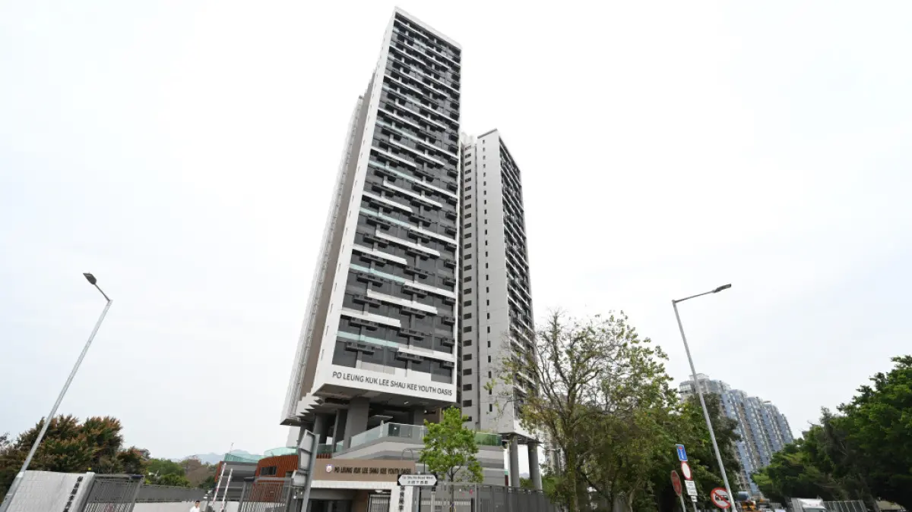

“Po Leung Kuk Lee Shau Kee Youth Oasis” (保良局李兆基青年綠洲), is the largest project under the government's Youth Hostel Scheme, located at 18 Tai Shu Ha Road West, Yuen Long, is operated by Po Leung Kuk.

It is 27-storey building, providing 1,680 hostel places for working youth aged 18 to 30. The project has successfully established a scalable and sustainable youth hostel operation model. To date, it has served approximately 2,000 young residents, organized around 700 programmes with over 33,400 participant attendances, and built a volunteer team of more than 2,500 youth members contributing over 14,000 service hours.

The provision of Youth Services at Youth Oasis, including the followings:

“Youth Oasis” aims to promote the holistic development of young people by establishing a diverse and integrated service platform that addresses their needs in physical and mental wellbeing, capacity building, social participation, and sustainable development. Anchored by four core service streams, the programme adopts a systematic and coherent activity design to nurture positive values, enhance individual competitiveness, and encourage active community engagement, thereby fostering both personal and societal growth.

- Healthy Living
This stream promotes positive development in the physical, mental, and spiritual dimensions of youth, supporting their psychological and social wellbeing. Through a range of activities such as mindfulness self-awareness workshops and singing bowl stress-relief sessions, participants are guided to cultivate a balanced and sustainable healthy lifestyle.

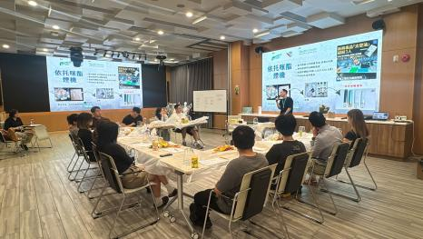  Anti-Drug Floral Art Workshop | 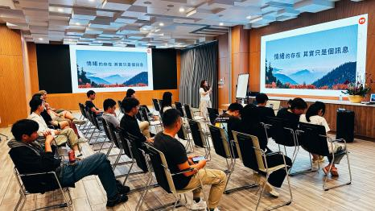  Mental Health Education Talk – Emotional Self-Awareness
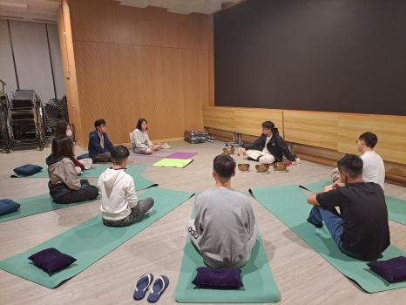
Singing Bowl Experience Workshop

2. Financial Planning
This stream focuses on strengthening youths’ career readiness, financial literacy, and entrepreneurial capabilities. It aims to cultivate sound financial habits and equip young people to plan effectively for their future, while providing diverse training and practical opportunities to support entrepreneurial exploration and enhance their understanding of different industries for informed career planning. Key initiatives include the “Learning Finance through Stories” series co-organised with the Investor and Financial Education Council, as well as financial planning workshops, one-on-one financial advisory services, and the “Career and Financial Literacy” workshops delivered in collaboration with the Mandatory Provident Fund Schemes Authority (MPFA).

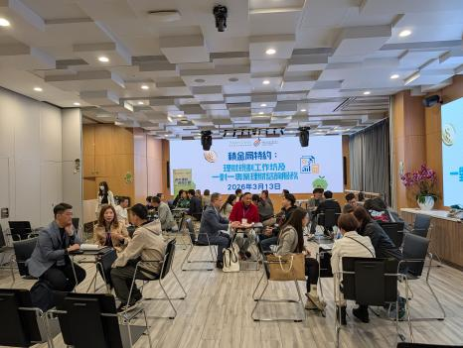  Financial Education – One-on-One Personal Advisory Service | 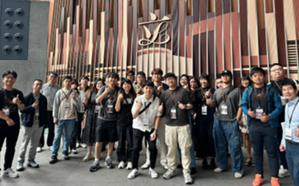  Legislative Council Visit
3. Volunteering
This stream develops youths’ capacity to plan and implement community service initiatives, fostering connections with underprivileged groups and promoting the value of “helping others to help themselves.” Activities include outreach programmes such as International Children’s Day visits and the summer “Care for the Elderly” campaign.

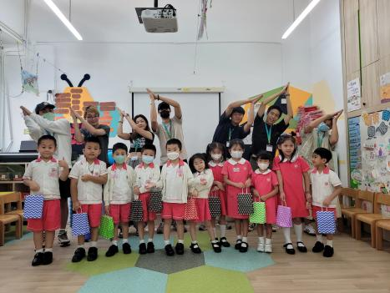  International Children’s Day Outreach Visit for Children | 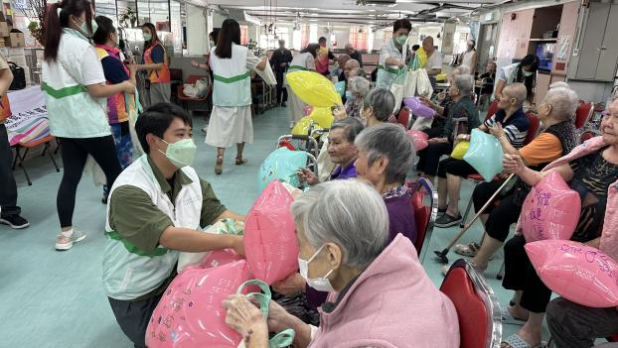  Summer “Care & Compassion for the Elderly” Activity

4. Green Culture
This stream enhances environmental awareness and encourages practical sustainable actions among youth. Through initiatives such as coastal clean-up programmes and visits to environmental education centres, participants are encouraged to integrate sustainability into their daily lives and develop a responsible attitude towards environmental stewardship.

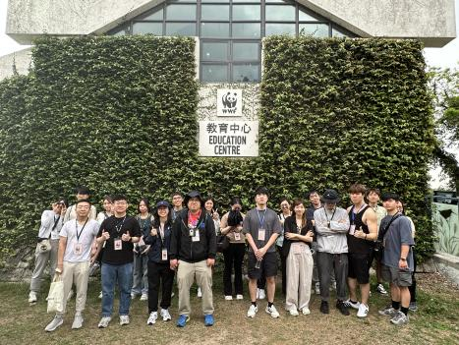  Visit to Environmental Education Centre | 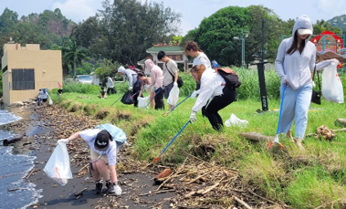  Coastal Clean-up and Environmental Stewardship Activity

Project Cost: | HK$33.4M
Completion: | 2025-2028
Funder & Overseer | The Education University of Hong Kong

  - Duties and Responsibility

The Duties and responsibility of the core personnel are as follow:

Name (Position) | Duties and Responsibility
LEE Tak Wai  Service Manager, Student Engagement and Community Programming  (On-site Team)  Report to Property Manager | Mr. Lee Tak Wai is a Registered Social Worker and will be the Project-in-charge on- and off-site for the hostel community services. He will oversee the planning and management for the hostel community services for the project. He will act as the Deputy of the Project Manager in case Ms Chan Siu Yu on leave. He will be responsible for the followings:  - Provide timely counselling and advisory support to exchange hostel youth in need, and make appropriate referrals as necessary.  - Respond immediately to serious incidents and emergencies.  - Oversee the overall on-site service operations, including activity planning, resource management, and service quality monitoring.  - Supervise the day-to-day implementation of services and collaborate with the team to discuss service content and direction.  - Provide guidance and professional advice to the team to ensure the quality and smooth execution of activities.  - Lead the team in conducting service quality and performance reviews, and formulate plans for continuous improvement and optimisation.  - Maintain close and positive relationships with partners.  - Manage personnel and project-related administrative tasks.
CHAN Siu Yu  Project Manager, Student Engagement and Community Programming  (On-site Team)  Report to Service Manager | Ms. CHAN Siu Yu is a Registered Social Worker and will lead the hostel community service team onsite and be responsible for the followings:  - Provide timely counselling and advisory support to youth staying in exchange hostels as needed, and make appropriate referrals when necessary  - Responsible for the implementation and management of designated projects, coordinating various service activities including event dates, venue arrangements and support, manpower deployment, etc.  - Ensure all activities are carried out as planned and that pre-set goals are achieved  - Provide guidance and professional advice to the team to ensure service quality and smooth execution of activities  - Maintain close and positive working relationships with partner organisations  - Liaise and coordinate with relevant parties and stakeholders when organising community activities  - Discuss and formulate annual plans and budget with the team on a yearly basis
AM Tsz Ying  Project Officer, Student Engagement and Community Programming  (On-site Team)  Report to Project Manager | Ms. LAM Tsz Ying will be the Chief Project Officer onsite and provide full support to the Service Manager and Project Manager the followings:  - Interact directly with youth and assist in the planning and execution of activities  - Prepare necessary materials and equipment for activities  - Liaise with external parties, including hostel residents, volunteers, and service providers  - Provide administrative support, including document preparation, meeting coordination, recruitment, and financial arrangements  - Manage resources, including supplies and assets, and maintain relevant records  - Assist in promotion and publicity efforts  - Handle team document organisation, data entry, and database maintenance  - Manage service procurement  - Prepare activity and financial reports
LO Chun Leung  Project Officer, Student Engagement and Community Programming  (On-site Team)  Report to Project Manager | Mr. Lo Chun Leung will provide full support to the Managers and the Chief Officer the followings onsite:  - Interact directly with youth and assist in the planning and execution of activities  - Prepare necessary materials and equipment for activities  - Liaise with external parties, including hostel residents, volunteers, and service providers  - Provide administrative support, including document preparation, meeting coordination, recruitment, and financial arrangements  - Manage resources, including supplies and assets, and maintain relevant records  - Assist in promotion and publicity efforts  - Handle team document organisation, data entry, and database maintenance  - Manage service procurement  - Prepare activity and financial reports

  - Organization Chart

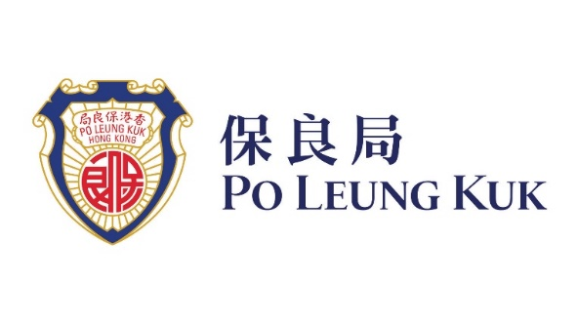



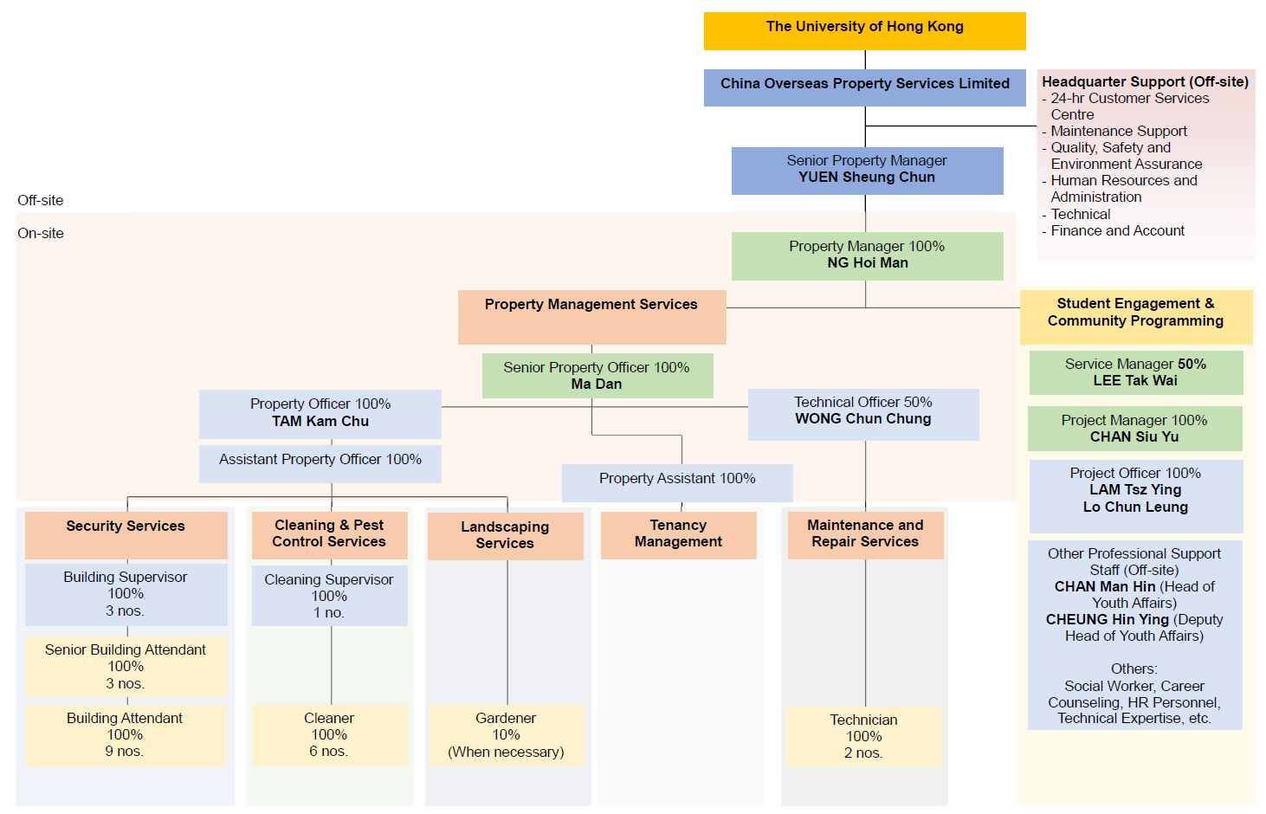

  - CV of Student Engagement and Community Services Provider
THE KEY PERSON FOR THE PROPERTY MANAGEMENT TEAM

Staff  assigned to this contract  (name) | Key person |  | Part 1 – Qualification |  |  |  | Part 2 – Experience
 |  |  | Professional Qualifications |  | Date of award (mm/yy) |  | Year of Post Qualification Experience in the capacity of the Position in this proposal |  | Employment Period
 |  |  |  |  |  |  |  |  | Company |  | Post |  | From  (dd/mm/yy) |  | To  (dd/mm/yy)
Student Engagement and Community Services Provider
LEE Tak Wai |  | Service Manager  (Key Person)  Student Engagement and Community Programming |  | Registered Social Worker |  |  |  | 17  Minimum Requirement for the Position proposed for this proposal:  - A minimum of 10 years’ post-professional qualification experience |  | Po Leung Kuk |  | Service Manager (Youth Affairs) |  | 2021 |  | Present
 |  |  |  | Projective Drawing Analyst |  |  |  |  |  |  |  | Supervisor (Children and Youth) |  | 2010 |  | 2021
 |  |  |  | Certificate of Accredited Mediator |  |  |  |  |  |  |  | Social Worker |  | 2008 |  | 2010
 |  |  |  | Personality Dimensions® Facilitator (Level 1)
 |  |  |  | Everything DiSC® Certified Facilitator
 |  |  |  | Trained facilitator of LEGO® SERIOUS PLAY® method and materials
 |  |  |  | LEGO®-based therapy facilitator
CHAN Siu Yu |  | Project Manager  Student Engagement and Community Programming |  | Registered Social Worker |  |  |  | 17  Minimum Requirement for the Position proposed for this proposal:  - A minimum of 8 years’ post-professional qualification experience |  | Po Leung Kuk Student Guidance and Support Services |  | School social worker |  | 2024 |  | Present
 |  |  |  | Projective Drawing Analyst |  |  |  |  |  | YWCA Jockey Club Family Wellness Centre |  | Social worker (part-time) |  | 2024 |  | 2024
 |  |  |  | Personality Dimensions Facilitator (Level 1) |  |  |  |  |  | Centre for Restoration of Human Relationships |  | School social worker (supply) |  | 2023 |  | 2023
 |  |  |  | Master Practitioner of Neuro Linguistic Programming |  |  |  |  |  | SRBCEPSA Lu Kwong Fai Memorial School |  | School social worker (part-time) |  | 2016 |  | 2023
 |  |  |  |  |  |  |  |  |  | HKFYG Student Guidance Team |  | Youth Work Officer |  | 2012 |  | 2013
 |  |  |  |  |  |  |  |  |  | HKFYG Jockey Club Verbena Youth SPOT |  | Youth Work Officer |  | 2008 |  | 2012
LO Chun Leung |  | Project Officer |  | N/A |  | N/A |  | - At least 4 years’ post-professional qualification experience |  | Po Leung Kuk |  | Youth Worker (Youth Oasis) |  | 2024 |  | Present
 |  |  |  |  |  |  |  | Excellent Global Business Limited |  | Senior Sales and Marketing Officer |  | 2022 |  | 2024 |  | Excellent Global Business Limited
 |  |  |  |  |  |  |  | Empire Hotel Hong Kong |  | Senior Events and Sales Executive  Events and Sales Executive  Events and Sales Executive (Joined as) |  | 2017 |  | 2022 |  | Empire Hotel Hong Kong
LAM Tsz Ying |  | Project Officer  Student Engagement and Community Programming |  | Challenge Course Association of HK, China |  |  |  | 1  Minimum Requirement for the Position proposed for this proposal:  - A minimum of 1 years’ post-professional qualification experience |  | Po Leung Kuk |  | Project Officer |  | 2025 |  | Present
 |  |  |  | (Low Event and High Event) Level 1 Technical Certificate and Assistant Instructor
 |  |  |  | Life Development Institute (Career Development Advisor (NCDA + CCSP))
 |  |  |  | Certificate in First Aid Course – Hong Kong St. John Ambulance
 |  |  |  | Mental Health First Aid - The Mental Health Association of Hong Kong

KEY PERSONS (1) FOR THE Student Engagement and Community SERVICES PROVIDER
Name of the key person: LEE Tak Wai
Current position: Service Manager

Registered Social Worker in Hong Kong under the Social Workers Registration Board since 2001
Accredited General Mediator of Hong Kong Mediation and Arbitration Centre since 2022
16 years’ professional supervisor experience in Youth Services

#Remark: (1) Similar Nature and Scope; (2) Universities, (3) Conversion, Design and Execution and completion of works at Residential Building, Hotel, Hostel; (4) Property Management at Residential building, Hotel Hostel; (5) other relevant experience
EXPERIENCE IN YOUTH SERVICES PROJECTS
COMPANY NAME | EMPLOYMENT PERIOD |  | POST | DUTIES | PROJECT TITLES | Annual Contract Sum ($M) | Details of experience in project (#Remark)
 | FROM  (dd/mm/yy) | TO  (dd/mm/yy
Po Leung Kuk | 2021 | Present | Service Manager | 16 years’ professional supervisor experience in Youth Services  - To be responsible for the planning, development and monitoring of the responsible units;  - To recruit, train and monitor a team of tenant selection and management;  - To communicate with internal departments, governmental departments and community organizations and parties to develop and maintain self-sustaining quality service with good accountability;  - To set up crisis prevention and emergency management policies;  - To prepare accurate and precise documentation and reports;  - To plan and manage budgets and financial issues;  - To handle the administration and personnel management; | Youth Adventure Training Activities/HYAB (25-27)  Youth Adventure Training Activities/HYAB (23-25)  Comprehensive Student Guidance Service (Every Year) | HK$6.5M  HK$6.9M  HK$18M | (5)
 | 2010 | 2021 | Supervisor
 | 2008 | 2010 | Social Worker

